**END UNJUST EVICTIONS!!!**

**REFORM HOUSING COURT!!!**

***NYC, PASS “INTRO 214-A”!!!***

“INTRO 214-A” WOULD GIVE NEW YORKERS THE RIGHT TO LEGAL REPRESENTATION WHEN FIGHTING FOR THEIR HOMES IN HOUSING COURT!

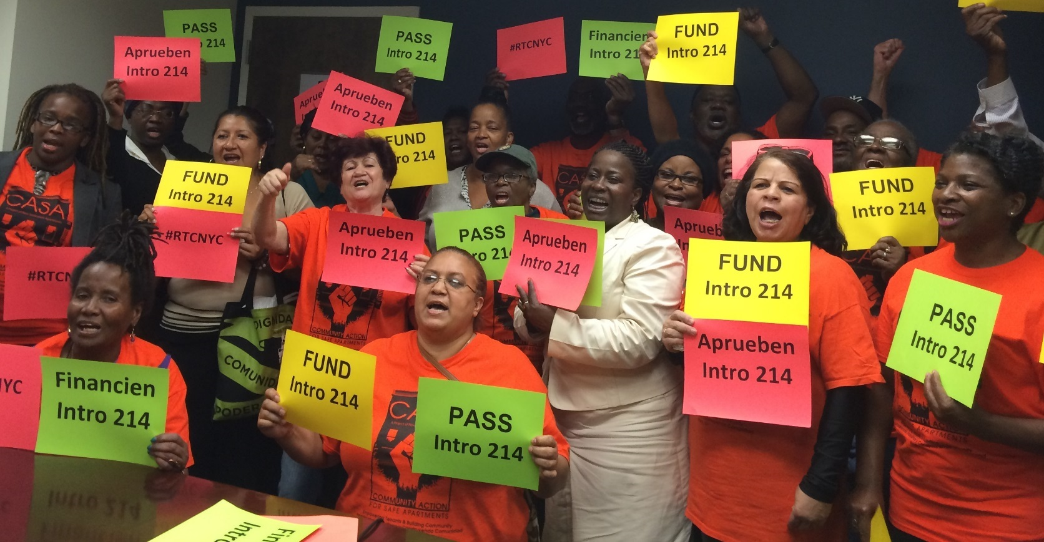

PRESS CONFERENCE AND CITY COUNCIL HEARING:

When: Monday Sept 26th

Meet CASA at 35 Marcy Place

(corner of Walton Ave.)

8:30AM SHARP!

Breakfast and metrocards provided.

WE NEED YOU TO HELP PASS “INTRO 214-A”!

* This is your ONLY opportunity to testify in front of city council to demand “Intro 214-A”

* NYC could save up $320 Million!!!

* Stop landlords from bringing frivolous court cases and harassment

* We can change the balance of power in housing court, where 90% of landlords have attorneys, while most tenants don’t!

http://www.righttocounselnyc.org

Need help with prepping testimony? Need an orientation on the Right to Counsel? Contact Susanna! Attend prep meeting on Tues. Sept 20th, 6:00pm at 35 Marcy Pl